Homework #2

Lavelle Burgess

Hawaii Pacific University

CSCI – Database Technologies

Professor: Azhar Ishaque

Date: 7 Apr 2019

**Page 108 – Problems 17-23**

**17. For each table, identify the primary key and the foreign keys(s). If a table does not have a foreign key, write None.**

**Table TRUCK**

**Primary Key: TRUCK_NUM**

**Foreign Keys: BASE_CODE, TYPE_CODE**

**Table BASE**

**Primary Key: BASE_CODE**

**Foreign Key: None**

**Table TYPE**

**Primary Key: TYPE_CODE**

**Foreign Key: None**

**18. Do the tables exhibit integrity? Answer yes or no, and then explain your answer.**

**Yes, each table has a primary key and each of the data elements for their primary keys are unique.**

**19. Do the tables exhibit referential integrity? Answer yes or no, and then explain your answer. Write NA (Not Applicable) if the table does not have a foreign key.**

**Yes, the foreign keys for table TRUCK contain values from the primary keys in BASE and TYPE tables. There is a null value for TRUCK:BASE_CODE, but that is one of two valid states.**

**20. Identify the TRUCK table’s candidate key(s).**

**The candidate keys for table TRUCK is TRUCK_NUM and TRUCK_SERIAL_NUM. These are unique identifiers for trucks**

**21. For each table, identify a superkey and a secondary key.**

**Table TRUCK**

**Superkey: TRUCK_NUM**

**Secondary Key: BASE_CODE, TYPE_CODE**

**Table BASE**

**Superkey: BASE_CODE**

**Secondary Key: BASE_CITY, BASE_STATE**

**Table TYPE**

**Superkey: TYPE_CODE**

**Secondary Key: TYPE_DESCRIPTION**

**22. Create the ERD for this database.**

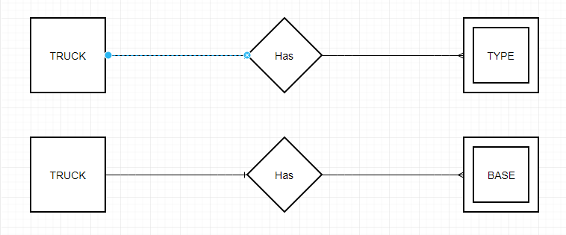

**23. Create the relational diagram for this database.**

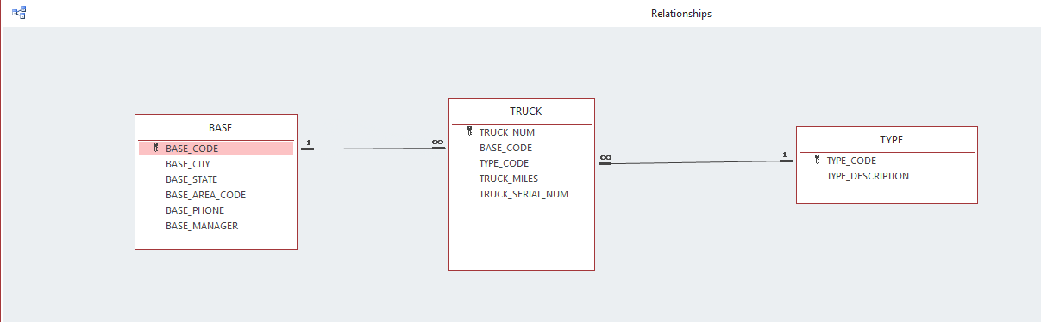

**Problem 29-31 (page 112).  Please attach the completed database file that will include the necessary able(s).**

**Deliverables.**

1. **HW #2 MS Word document file with appropriate screen shots**
2. **MS Access database file**

*Remember to provide a list of online resources used for homework #2.*

<https://www.draw.io/> To make the ERD

References

Text Book and any additional resources used.

Database Systems: Design, Implementation, & Management